Cointegration and ECM: AUDUSD and NZDUSD
Method 27 / Engle-Granger on log closes / one-lag ECM / Alpari D1 full available history

Study setup
Logical pair: PX=AUDUSD , PY=NZDUSD
Broker symbols: AUDUSD_i , NZDUSD_i
Snapshot: 2026-11-03_majors_alpari_D1
Timeframe: D1
Matched window: 1999-01-05 to 2026-11-02 (UTC bar dates)
Matched level count n: 7202
Dropped unfinished last bar dated 2026-11-03 UTC after a tick-volume check against the prior complete day.
ECM lags of deltas: 1
Complete matched rows (Excel): AUDUSD-NZDUSD_Coint_D1.xlsx
Complete matched rows (HTML table): AUDUSD-NZDUSD_Coint_D1_data.html

Method carried forward
Engle-Granger cointegration works on log price levels, not returns. For each unordered pair, PX is the left leg and PY the right leg. Step one: OLS ln(PY) = alpha + beta * ln(PX) + e. Step two: statsmodels Engle-Granger coint test on (ln(PY), ln(PX)). Error-correction: delta ln(PY)_t = c + kappa * e_{t-1} + lagged delta ln(PY) and delta ln(PX) (one lag each) + u_t. Headline is the Engle-Granger p-value (lower = stronger evidence of a stationary spread) with kappa and beta reported alongside. Same-sample Pearson r of log returns is a side check only. beta is not an automatic lot-size hedge. This is not a trading signal.

Results (headline)
alpha: -0.160941
beta: 0.914132
Engle-Granger t: -2.443248
Engle-Granger p: 0.304655
5% critical value: -3.336979
ECM kappa: -0.002031
kappa t-stat: -1.5657
ECM R^2: 0.000760
spread std: 0.069516
Pearson r (returns): 0.828722

Conclusion
Engle-Granger for PY=NZDUSD on PX=AUDUSD: beta=0.9141, alpha=-0.1609, coint_t=-2.4432, p=0.3047 (5% crit=-3.3370). ECM kappa=-0.0020 (t=-1.57). Pearson r of returns = 0.8287. beta is not a lot-size hedge. Not a trading signal.

Charts
Daily closes

Engle-Granger residual spread
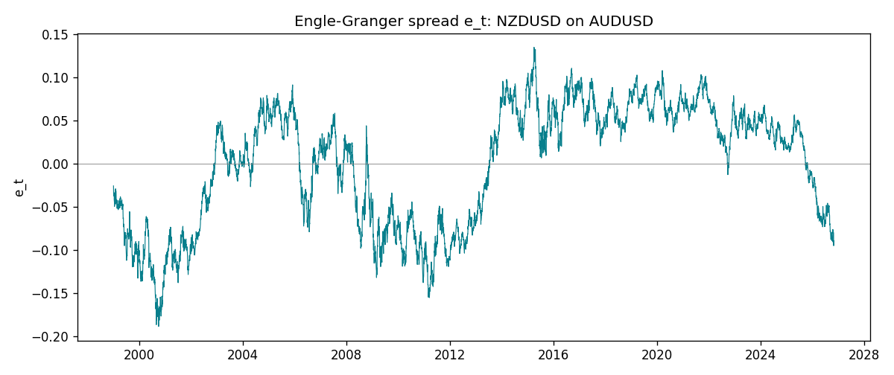
Daily log returns
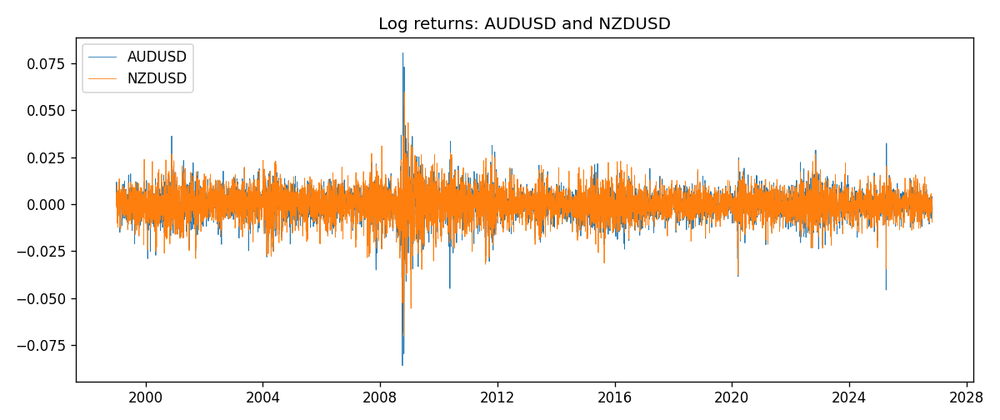

Data report
Matched rows are in the sibling Excel workbook named AUDUSD-NZDUSD_Coint_D1.xlsx. Embedding all rows as a Word table is impractical; this file holds column summaries and the first and last 15 matched rows.
Column summaries
column | count | mean | std | min | 25% | 50% | 75% | max
AUDUSD_open | 7202 | 0.75190973 | 0.13530408 | 0.4785 | 0.6610275 | 0.731395 | 0.8089525 | 1.10284
NZDUSD_open | 7202 | 0.65620671 | 0.10825448 | 0.3913 | 0.5910925 | 0.6683 | 0.724695 | 0.88218
AUDUSD_high | 7202 | 0.75595988 | 0.13586572 | 0.4878 | 0.6647 | 0.734725 | 0.81501 | 1.10795
NZDUSD_high | 7202 | 0.66012182 | 0.1087492 | 0.3961 | 0.5946275 | 0.67189 | 0.7292675 | 0.88421
AUDUSD_low | 7202 | 0.74785283 | 0.13461673 | 0.4775 | 0.6577 | 0.727385 | 0.8042 | 1.0975
NZDUSD_low | 7202 | 0.6525168 | 0.10784895 | 0.3897 | 0.587955 | 0.66406 | 0.72082 | 0.87988
AUDUSD_close | 7202 | 0.75195766 | 0.13528533 | 0.4786 | 0.6611925 | 0.731645 | 0.809065 | 1.10169
NZDUSD_close | 7202 | 0.65627751 | 0.10825012 | 0.3907 | 0.59141 | 0.668305 | 0.7249175 | 0.8822
AUDUSD_tick_volume | 7202 | 77337.3 | 138128.78 | 109 | 5435.5 | 43320 | 71312.25 | 1234623
NZDUSD_tick_volume | 7202 | 68561.899 | 123036.41 | 17 | 5505.5 | 33822 | 58470.25 | 1127682
AUDUSD_spread | 7202 | 30.821161 | 16.887481 | 0 | 13 | 30 | 50 | 50
NZDUSD_spread | 7202 | 30.366287 | 25.672101 | 0 | 9 | 17 | 50 | 80
AUDUSD_real_volume | 7202 | 5.2413627e+09 | 1.253718e+11 | 0 | 0 | 0 | 0 | 3.811512e+12
NZDUSD_real_volume | 7202 | 1.6659405e+10 | 8.488719e+10 | 0 | 0 | 0 | 0 | 2.705649e+12
AUDUSD_log_price | 7202 | -0.30084006 | 0.17694689 | -0.7368901 | -0.41371026 | -0.31245986 | -0.21187604 | 0.09684536
NZDUSD_log_price | 7202 | -0.43594874 | 0.17605781 | -0.93981528 | -0.52524576 | -0.40301062 | -0.32169742 | -0.12533649
AUDUSD_log_return | 7202 | 2.237e-05 | 0.00754318 | -0.08602525 | -0.00386318 | 0.00028132 | 0.00415217 | 0.0806166
NZDUSD_log_return | 7202 | 5.13e-06 | 0.00764596 | -0.07027433 | -0.00426304 | 0.00021271 | 0.00457975 | 0.05966839
spread_e | 7202 | 0 | 0.06951552 | -0.18886251 | -0.06499245 | 0.022079 | 0.05752715 | 0.13516681
ecm_fitted | 7201 | 5.39e-06 | 0.00021078 | -0.00078768 | -0.00014255 | -1.719e-05 | 0.00013821 | 0.00145419
First 15 matched rows (selected columns)
time | AUDUSD_log_price | NZDUSD_log_price | spread_e | AUDUSD_log_return | NZDUSD_log_return
1999-01-05 | -0.47561937 | -0.62138481 | -0.025664798 | -0.00080418179 | -0.0018597736
1999-01-06 | -0.46378302 | -0.61933925 | -0.034439218 | 0.011836351 | 0.0020455609
1999-01-07 | -0.45491799 | -0.61304294 | -0.036246701 | 0.0088650256 | 0.0062963171
1999-01-08 | -0.45460283 | -0.6135969 | -0.037088763 | 0.00031515916 | -0.00055396548
1999-01-11 | -0.44738145 | -0.60330648 | -0.03339963 | 0.0072213815 | 0.010290425
1999-01-12 | -0.4522423 | -0.60862223 | -0.034271924 | -0.0048608485 | -0.0053157489
1999-01-13 | -0.46013251 | -0.61859645 | -0.037033459 | -0.0078902098 | -0.0099742238
1999-01-14 | -0.46282943 | -0.6187821 | -0.034753772 | -0.002696916 | -0.00018564931
1999-01-15 | -0.45570632 | -0.61952504 | -0.042008165 | 0.007123101 | -0.00074294208
1999-01-18 | -0.4547604 | -0.62138481 | -0.044732638 | 0.00094592471 | -0.0018597736
1999-01-19 | -0.44753788 | -0.61952504 | -0.049475194 | 0.0072225153 | 0.0018597736
1999-01-20 | -0.4462871 | -0.61544567 | -0.046539205 | 0.0012507819 | 0.0040793678
1999-01-21 | -0.44550616 | -0.61138288 | -0.043190297 | 0.00078094498 | 0.0040627941
1999-01-22 | -0.4577589 | -0.62343457 | -0.044041366 | -0.012252745 | -0.012051689
1999-01-25 | -0.46171805 | -0.62698498 | -0.043972595 | -0.0039591468 | -0.0035504102
Last 15 matched rows (selected columns)
time | AUDUSD_log_price | NZDUSD_log_price | spread_e | AUDUSD_log_return | NZDUSD_log_return
2026-10-13 | -0.35923536 | -0.57755321 | -0.088223479 | 0.0035007712 | 0.0047326165
2026-10-14 | -0.36075468 | -0.58128385 | -0.090565268 | -0.0015193215 | -0.0037306483
2026-10-15 | -0.36829939 | -0.57652037 | -0.078904928 | -0.0075447063 | 0.0047634855
2026-10-16 | -0.36490875 | -0.57077027 | -0.07625432 | 0.0033906408 | 0.0057501001
2026-10-19 | -0.35982275 | -0.56887856 | -0.079011878 | 0.0050859986 | 0.0018917133
2026-10-20 | -0.35636071 | -0.56515862 | -0.078456706 | 0.0034620426 | 0.0037199341
2026-10-21 | -0.35275407 | -0.56206629 | -0.078661315 | 0.0036066384 | 0.0030923331
2026-10-22 | -0.35402133 | -0.56536981 | -0.080806399 | -0.0012672558 | -0.0033035227
2026-10-23 | -0.35164476 | -0.56227683 | -0.079885908 | 0.0023765656 | 0.0030929853
2026-10-26 | -0.35484804 | -0.56517622 | -0.079857079 | -0.0032032829 | -0.0028993932
2026-10-27 | -0.35318105 | -0.56544022 | -0.081644923 | 0.0016669876 | -0.00026399852
2026-10-28 | -0.3490895 | -0.57516861 | -0.095113533 | 0.0040915541 | -0.0097283914
2026-10-29 | -0.35318105 | -0.5745467 | -0.090751408 | -0.0040915541 | 0.00062190714
2026-10-30 | -0.35217082 | -0.57435132 | -0.091479521 | 0.0010102376 | 0.00019537668
2026-11-02 | -0.35708932 | -0.57694762 | -0.089579662 | -0.0049184984 | -0.0025962955

